A2360-MEX-Olmec-Were Jaguar-Mask-Jade-1100 BCE

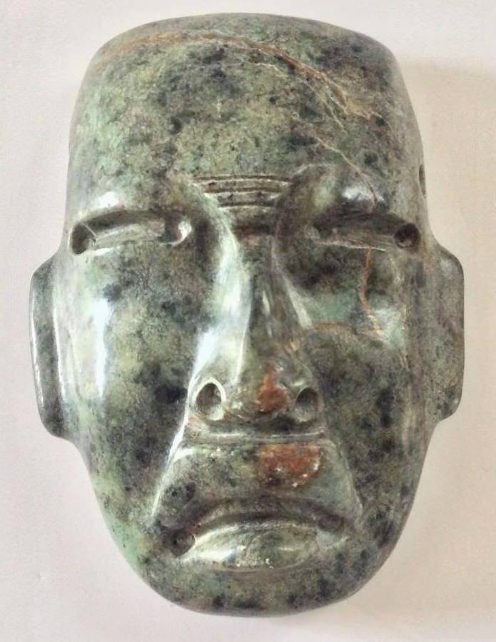 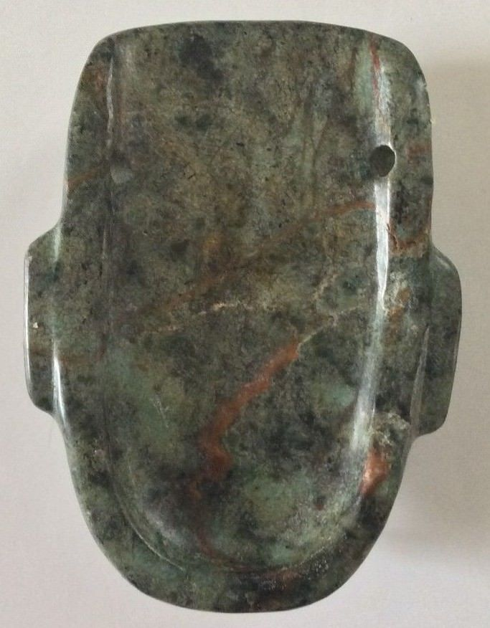 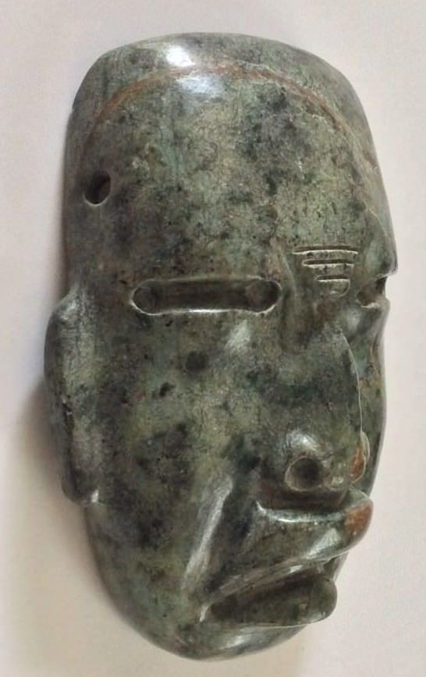

Figs. 1-3. Olmec-Were Jaguar-Mask-Jade-1100 BCE

**Case no.: 14**

**Accession Number:**

**Formal Label:** MEX-Olmec-Mask-Serpentine-1100 BCE

**Display Description:**

This is a were-jaguar transformation mask that emphasizes feline wrinkles around the nose, upcurving lips and bared teeth. It was probably worn around the neck as a pendant and may have given the wearer a new identity, perhaps that of a were-jaguar ancestor, because the Olmecs believed that, in the distant past, a union between a woman and a jaguar produced an earlier race of were-jaguars. The Olmecs worked mainly in stone and used mottled serpentine to suggest the mysterious transformative aspect of human to were-jaguar conversion.

**LC Classification:**

**Date or Time Horizon:** 1100 BCE

**Geographical Area:** possibly La Venta

**Map:**

**GPS coordinates:**

**Cultural Affiliation:**

**Media:**

**Dimensions:** H 2 ½ in, W 1 7/8 in ,T 7/8 in

**Weight:**

**Condition: original**

**Provenance:**

**Discussion:**

The Olmecs, the earliest known settled civilization of Central America, lived in the low-lying Gulf Coast area of what is now Mexico in about 1200-400 BCE at sites such as San Lorenzo, Tres Zapotes, Laguna de los Cerros and La Venta.

These and the other Olmec centers were well planned and included many of the features that would be associated with later civilization in Central America including the Mexica (Aztecs) and Maya. Alongside impressive public spaces and large platform-mounds made of earth, there is evidence of a ceremonial ball game and complex astrological calendars.

**References:**